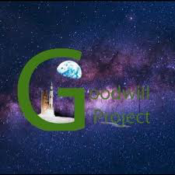
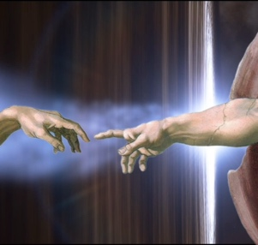
Stay positive, just ignore people who like conflicts vote
David Thelen for Governor

The devil feeds on souls filled with hate and fear. People are afraid of losing a rich image and becoming ignored. Do not feed a soul who worship the Golden Calf, the ones with big Houses, boats, fancy cars, gold. If we do, the devil will destroy humankind with nukes.


To counteract these negative Impulses, the media should broadcast Goodwill scenes. I will use the Governor Bully Pulpit to spread hope and Peace while wearing my hat.

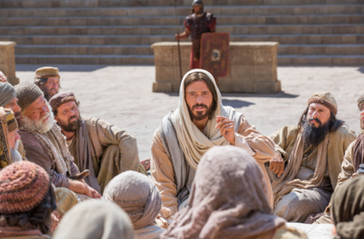

Let us learn how a helicopter flies, it needs the Tail blade to keep the helicopter from crashing.

All wars, police versus the demonstrators, Ukraine versus Russia, Israel versus Iran, conservatives versus liberals need a Goodwill blade mixed in preventing it turning’ into a riot or nuclear war. That is why the military, or police need to be seen transporting food, water, medicines, and especially Goodwill postcards made by kids of the other side.

As it pertains to how a helicopter flies. the top blade is like one nation,
or groups of people. When the top blade turns in one direction, missiles, drones, show of force, then there is the body of the helicopter turning the opposite direction with missiles drones, or goodwill back. The bigger the top blade turning, action or Military strikes, the more hate reaction from the other side will do. We learn this, then we create safer streets and more peace!

Reinventing California by 2060. Thelen4californiaGovernor.com
Reducing Food Prices, decrease housing costs, stopping traffic grid locks. David Thelen
Fresh creative rezoning needs to be done period before more housing can be built where roads used to be. The other way to build more housing is to build up. For things to flow like water faster, it cannot be met with squares up ahead downstream, but that of curves. The surfaces of the roads still must be greater than what’s flowing in it, but also in curves formation.
A new project moon shot 2060 plan would organize contests for experts, Regular people, and even small kids with Legos to offer ideas how this system would work. They would compete for prizes funded by private companies. Teams of people would compete for winnings to propose how this traveling and commerce movement pathways system would look like by 2060.
Along the Routes, it would include roadway, railway, seaway, tunnels, and air be where it can be done. To developed tubes of rail, air, balloon types of shredded plastics tubes would be created, It’s not developed yet, but it will if only wars stop.

New miniature passenger vehicles could also serve as an entertainment center parked in your family room. If a person wants to travel using this mini vehicle it can be reconfigured like the toy transformer, the base magnetic rotator could be programmed by one press the button in the vehicle so it can go into action and have you traveling like that of the bank teller system. It could be like that of putting a canister in a tube at a banks drive through teller system. New vehicles which is miniature in size but large enough it can fit two people comfortably in it.
Commerce, like food, vegetables, milk, etc could be placed in larger tube vehicles. It will be vacuumed through the vacuum system right to even your front door for food. Some countries have already developed tubes high speed trains that run as high as almost 700 mph, these larger tubes can hold the food to be quickly transported to kitchens, restaurants, and food kitchens before the food goes bad.
Kennedy had proposed the moon-shot project in 1961 that we will land a man on the moon by the end of the decade, I say by 2060, we will revolutionize transportation and where we live at lower costs.

Lowering the cost of living, Vote David Thelen for Governor
Allow deferring student loan payments to start a family,
Create economic challenge zones; sales tax on restaurant food will be close to 0 so more tips can be paid for the wait staff, Gasoline and diesel taxes will be reduced to almost 0; Hotel taxes will also be almost zero in these economic challenge zones - non challenge neighborhoods may see a little increase in sales tax and fuel tax to make up the difference.
Property taxes will decrease in these zones for essential workers like nurses, teachers, police, military personnel. Create new classification of being an attorney when dealing with real estate; it will take only three years to pass the coursework.
Competition among these new classification of attorneys will reduce the cost of exchanging real estate for buyers and sellers alike; whether first time home buyer or retirees will benefit from needing to pay such high costs to close on the housing contract.

Education – Vote David Thelen for California Governor independent
Education is a life long event 1st I will advocate an increase in prenatal care; I will advocate women who are expecting are not living in homes that have lead paint and lead pipes to drink water from. 2nd I will advocate and set up a team of 6 parents can get together to watch each other's kids while 1-2 or three of them get more education, do chores etc, a volunteer from an university will guide pre schools are run.
Learning social skills is the most important part of education today; society has a problem listening feeling having empathy towards others; a big part I believe is because at an early age, we trained students to be good test takers by themselves not to be aware of people around them. I will advocate elementary schools concentrate on social skills so to reduce drug abuse or being greedy later on in life.
Visit thelen4californiagovernor.com

